Preparation and Trial of the

Property Tax Assessment

Appeal Seminar
June 5 - 6, 2014
University of Missouri - Kansas City (UMKC)

School of Law

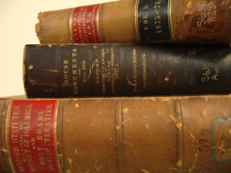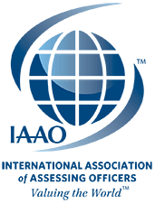

Olson & Olson, LLP’s attorney Jim Robinson spoke at the IAAO Conference recently during their 2-day training on “Deposition Techniques & Trends.” The conference also included sessions on trial advocacy, making the decision to go to trial, implications of Daubert & Frye, electronic evidence and the use of technology at trial. Training also included presentations, mock trial vignettes, video demonstrations, and panel discussions. The subject property of the trial re-enactment is a hotel.
O&O attorneys Andrea Chan and Jenny Rogers, also attended and participated in conference activities.

